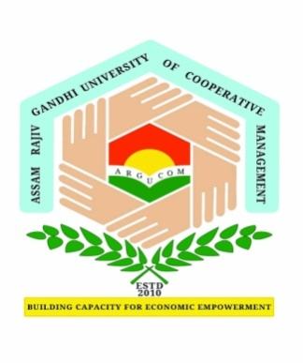
Assam Rajiv Gandhi University of Cooperative Management
(A Govt. of Assam University)
Recognised by UGC and member of Association of Indian Universities
Basic Tinali, Gadadhar Nagar, Joysagar, Sivasagar
Email: info.argucom@gmail.com

Ph. D.

APPLICATION FOR EXTENTION OF REGISTRATION AS A STUDENT FOR DEGREE OF Ph. D.
To, Date:………………
The Registrar,
Assam Rajiv Gandhi University of Cooperative Management, Sivasagar

Dear Sir/Madam,

I am a registered student for the degree of Doctor of Philosophy of Assam Rajiv Gandhi University of Cooperative Management, Sivasagar in the subject under
the School of ……………………………..…………………………..….., Registration No ,
<Title>……………………………………………………………………………………………………………….…………………………………
………………………………………………………………………………………………………………………………………….……..………. I have completed ………..%...........................of research work and I need …………………….<time>……………….more to complete my Ph. D. research work.
I request you to give me an extension of …..<time> to submit my thesis as per Ph. D. Regulations. I will pay the prescribed fee.

.

Yours faithfully,

Name & Signature

Address ………………………………………………

Mobile No. ………………………………………..

E-mail : ……………………………………………….

Recommendations of Supervisor:

…………………………………………………………………………………………………………………………………………………………
…………………………………………………………………………………………………………………………………………………………
…………………………………………………………………………………………………………………………………………

Name & Signature of Supervisor

Recommendations of Joint Supervisor (if any):

…………………………………………………………………………………………………………………………………………………………
…………………………………………………………………………………………………………………………………………………………
…………………………………………………………………………………………………………………………………………

Name & Signature of Joint Supervisor

